Poetry Review
June Exemplars: Poetry Reviews by Grace Cavalieri
June 20, 2013
Elvis Presley’s Hips & Mick Jagger’s Lips by Susana H. Case. Anaphora Literary Press. 75 pgs.
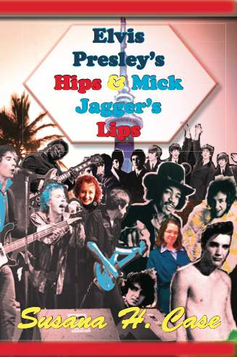
This is an encyclopedia of rock ‘n roll in personalized poetic messages. These are flinty pieces reeling from the mean streets of the music business with youthful hope that the strength of a generation is in the glamour of the heat. In the early part of the 20th century, there was a mantra, “Mama didn’t allow no blues or jazz.” These poems tell what happens if she did. They are tough and live in the world of drugs and seduction; the relationships are unflinching too with the musical chords of discontent and misplaced love. The book is not a downer with all that; it’s elegiac and denotes a time and place in our culture where rock music thought it had trumped over age and dying. There are strong synergistic bits of heart and soul here of one poet addicted to a primal beat.

A Cathedral of Affection
Your cathedral of sound—
explodes only in my ears
in mono
in stereo
any noise will do.
The way you do it in the shower—
sing along with baby I love you,
the oomph of woa-oh oh oh.
I challenge you to hit the high notes,
give me some handclaps,
a little Leon Russell on the piano,
Darlene Love to back you up.
Sing with the feistiness of the Ronettes
—Their Washington Heights fight.
Your other fans don’t tingle on your lips.
You sing this way for me,
Your bad girl,
Your dancing girl,
Your girl to end all girls.

